Homework Feedback 9

2016/11/29

Weiwei Xu

**P. 494 #5** Given the data:

$x_{i}$ 4.0 4.2 4.5 4.7 5.1 5.5 5.9 6.3 6.8 7.1

$y_{i}$ 102.56 113.18 130.11 142.05 167.53 195.14 224.87 256.73 299.50 326.72

a. Construct the least squares polynomial of degree 1, and compute the error.

b. Construct the least squares polynomial of degree 2, and compute the error.

c. Construct the least squares polynomial of degree 3, and compute the error.

d. Construct the least squares approximation of the form $be^{ax}$, and compute the error.

e. Construct the least squares approximation of the form $bx^{a}$, and compute the error.

**Answer:** Follow the least squares rule to compute the matrix to solve for the parameters:

1. For polynomial degree 1, its formula should be $ax+ b=y$, where $a,b$ should be the parameters to be computed while fitting to the input data.
2. For polynomial degree 1, its formula should be $ax^{2}+ bx+c=y$, where a,b,c should be the parameters to be computed while fitting to the input data.
3. For polynomial degree 1, its formula should be $ax^{3}+ bx^{2}+cx+d=y$, where a,b,c,d should be the parameters to be computed while fitting to the input data.
4. For the function of the form $be^{ax}$, its linearization should be $\ln{b}+ax=\ln{y}$. First, we compute the $\ln{b}$ and a using linear least squares fitting, then convert it back to the its original form.
5. For the function of the form $bx^{a}$, its linearization should be $\ln{b}+a\ln{x}=\ln{y}$. The rest steps are similar to the answer of d.

**P. 506 #3** Find the linear least squares polynomial approximation on the interval $\left[-1,1\right]$ for the following functions.

a. $f\left(x\right)=x^{2}-2x+3$ b. $f(x)=x^{3}$

c. $f(x)=\frac{1}{x+2}$ d. $f(x)=e^{x}$

e. $f\left(x\right)=\frac{1}{2}\cos{x}+\frac{1}{3}sin2x$ f. $f(x)=\ln{(x+2)}$

**Answer:** Obviously, we needs to construct ***linear*** orthogonal polynomial functions on the interval $\left[-1,1\right]$ to construct the polynomial approximation of the given functions, then follow the rule of orthogonal least squares to compute the integration of the product of the polynomial function and the input functions.

On interval $\left[-1,1\right],$ the linear orthogonal polynomials are just 1, x. Let me take d. $f\left(x\right)=e^{x} as an example:$

First,

$\int_{-1}^{1}{1}dx=2$, $\int_{-1}^{1}{x^{2}}dx=\frac{x^{3}}{3} |_{-1}^{1}=\frac{2}{3}$

Second,

$\int_{-1}^{1}{e^{x}}*1dx=e-\frac{1}{e}$ = 2.35040

$\int_{-1}^{1}{{xe}^{x}}dx= {xe}^{x}|_{-1}^{1}-\int_{-1}^{1}{e^{x}}dx=\frac{2}{e}=0.73576$

Therefore: $f\left(x\right)=e^{x}≈\frac{2.35040}{2}+\frac{0.73576}{0.666667}x=1.17520+ 1.103639x$

**P. 506 #11** Use the Gram-Schmidt procedure to calculate $L_{1},L_{2}$ and $L_{3}$ where $\left\{{L_{0},L}_{1},L_{2},L_{3}\right\}$ is an orthogonal set of polynomials on $\left(0,∝\right)$ with respect to the weight functions $w\left(x\right)=e^{-x}$ and $L_{0}\left(x\right)=1$. The polynomials obtained from this procedure are called the **Laguerre polynomials.**

**Answer:** See example 3 on page 505 in the textbook for the answer.

**P. 517 #3** Use the zeros $of \tilde{{ T}_{4}}$ to construct an interpolating polynomial of degree 3 for the functions in Exercise 1.

**Answer:** The root of $\tilde{{ T}_{4}}$ is 0.92388, 0.3826, -0.3826, -0.92388. We only need to compute the function values in exercise 1 at the roots to construct the Lagrange polynomial or Newton method using divided difference.

**P. 517 #7** Find the sixth Maclaurin polynomial for $\sin{x}$, and use Chebyshev economization to obtain a lesser-degree polynomial approximation while keeping the error less than 0.01 on [-1, 1].

**Answer:** Maclaurin polynomial is the Taylor polynomial expanded at $x=0$. Therefore, the sixth Maclarin polynomial for $sinx$ is as follows:

$$sin⁡(x)≈x-\frac{x^{3}}{3!}+\frac{x^{5}}{5!}+\frac{1}{7!}\sin^{7}(ϵ)x^{7}$$

According to Chebyshev economization, the lesser degree of polynomial can be obtained by subtracting Chebyshev polynomials. First of all, the Chebyshev polynomial

$T_{0}\left(x\right)= 1$, $T_{1}\left(x\right)= x$, $T_{2}\left(x\right)= 2x^{2}-1$, $T_{3}\left(x\right)= 4x^{3}-3x$,

$T_{4}\left(x\right)= 8x^{4}-8x^{2}+1$, $T_{5}\left(x\right)= 16x^{5}-20x^{3}+5x$

First, we reduce the polynomial from 5th to 3th degrgee:

$$P_{3}\left(x\right)= x-\frac{x^{3}}{3!}+\frac{x^{5}}{5!}- \frac{1}{5!}\frac{T_{5}\left(x\right)}{16}=0.9973958x-0.15625x^{3}$$

Let us make sure the error is less than 0.01

$\max_{[-1,1]}\left|\sin\left(x\right)-P_{3}\left(x\right) \right|<\max_{[-1,1]}\left|\sin\left(x\right)-P_{4}\left(x\right) \right|+\frac{1}{5!*16}\max_{[-1,1]}\left|T_{5}\left(x\right)\right|=\frac{1}{7!}+ \frac{1}{5!*16}=7.19*{10}^{-4}$

Typical errors：

1. Calculate the approximation polynomial with minimum infinite norm, not chebyshev economization:

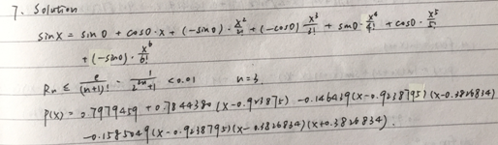

1. Forget the error in the Maclaurin polynomial approximation

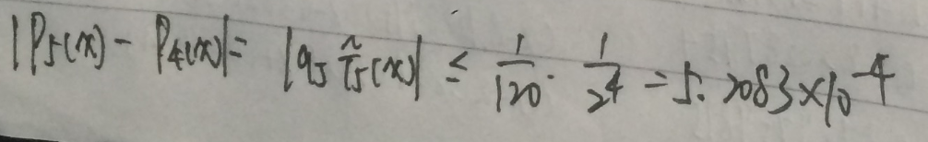

**P. 517 #9** Show that for each Chebyshev polynomial $T_{n}(x)$,we have:

$$\int_{-1}^{1}{\frac{{\left[T_{n}(x)\right]}^{2}}{\sqrt{1-x^{2}}}}dx=\frac{π}{2}$$

**Answer:** Since $\frac{d(arccos\left(x\right)) }{dx}=-\frac{1}{\sqrt{1-x^{2}}}$**,** we have:

$$\int_{-1}^{1}{\frac{{\left[T_{n}(x)\right]}^{2}}{\sqrt{1-x^{2}}}}dx=\int_{-1}^{1}{\frac{{\left[\cos{(narccos\left(x\right))}\right]}^{2}}{\sqrt{1-x^{2}}}}dx=\int_{-1}^{1}{{\left[\cos{(narccos\left(x\right))}\right]}^{2}}-darccos\left(x\right)= \int_{0}^{π}{{\left[\cos{(ny)}\right]}^{2}}dy=\int_{0}^{π}{\frac{\cos{2ny}+1}{2}}dy=\frac{π}{2}$$